Xamarin Installation Notes, east tamaki

In order to get xamarin working correctly the following steps must be taken

**1/**

**The SDK Locations ( set in Xamarin Studio**

**(Tools > Options > SDK Locations > Android)** are as follows

Android SDK C:\Android

Java SDK(JDK) C:\Program Files\Java\jdk1.7.0_51

2/

**After Android SDK install** (and possibly after updates?) the emulators may fail to start unless the .android folder is copied from the network drive

\\telmar\....\.android (in Hamilton) or \\coaklfs\userfiles$\James.Hancock\.android ( east tamaki)

TO=> the c: drive

C:\Users\james.hancock\.android

3/ **Projects may fail to build in the emulators** due to an Assembly syncronisation error, this only occurs when using emulators, The work around is to

-load a project

-go to bottom of the Project dropdown

- click <filename>options,

-in the left pane click Android build

- then untick Fast Assembly Deployment.

- build the project , wait for the emulator to start ( 6-8 minutes first time)

**4/**

All machines with the android sdk can run the **DDMS monitor** but only if called from within the xamarin apps sdk console. TOOLS > Open SDK command prompt “monitor.bat”.( which is fine)

**5/ USB drivers**

I did this on my home pc 8.1/32 bit

Walkthrough for installing generic drivers

In order to get my Vodafone smart 4 turbo ( fairly common android phone) to connect via USB debugging I had to do the following

1/ remove all phone based USB drivers from my computer, via device manager ( click uninstall device drivers if tickbox exists)

**I then used "**[**http://www.nirsoft.net/utils/usbdeview.zip**](http://www.nirsoft.net/utils/usbdeview.zip)**" and deleted all grey shaded drivers that contained anything like android/google/adb etc**

I then downloaded <http://www.koushikdutta.com/post/universal-adb-driver>

and ran the executable

rebooted

plugged in device

**back in device manager, right click on device with yellow ? - Select update drivers**

**Click “browse my PC for driver software”**

**— DO """NOT""" locate the driver by pointing the dialog to a directory**

**choose the second option: “let me pick from a list of device drivers on my PC”**

**locate the “Android Device” in the list**

**A list of models will appear**

**Select (“Android Composite ADB Interface”)**

**answer “Yes” to the “Update Driver Warning” ( Note these drivers are UNSIGNED)**

start xamarin, it now recognises both a samsung galaxy and my vodafone S4T .

Note that at Vision college despite this driver being installed, neither phone ( samsung or Vodafone 858 ) wants to use the driver, but I can’t point it to the driver without admin rights.

**Troubleshooting**

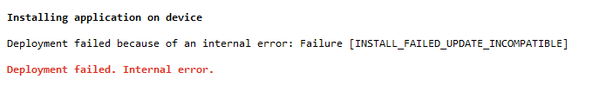

This error usually occurs when the application is not properly uninstalled from the device.

Go to yours Android Application Manager - > Search for the app you are debugging and uninstall it

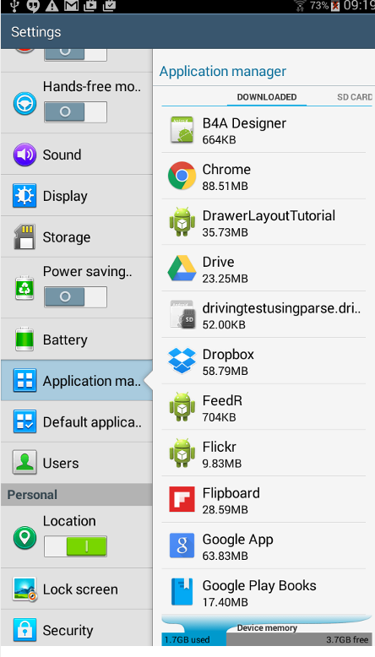

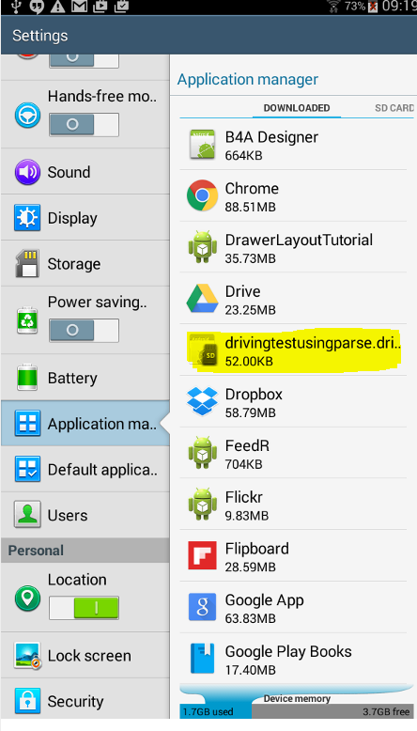 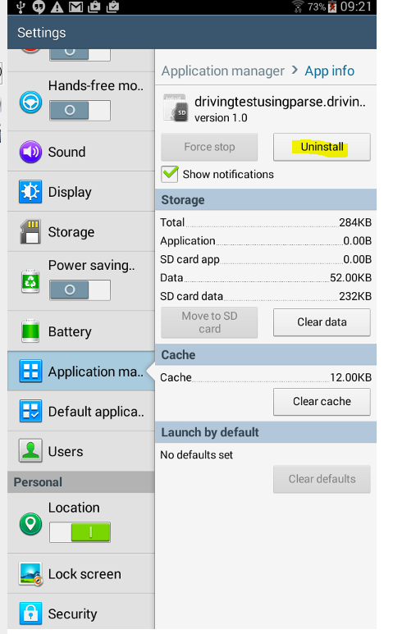

Find your app and uninstall it

**Projects may fail to build in the emulators** due to an Assembly syncronisation error, this only occurs when using emulators, The work around is to

-load a project

-go to bottom of the Project dropdown

- click <filename>options,

-in the left pane click Android build

- then untick Fast Assembly Deployment.

- build the project , wait for the emulator to start ( 6-8 minutes first time)

**Compile to Dalvik**

For this error you need to change the Java Heap Size.

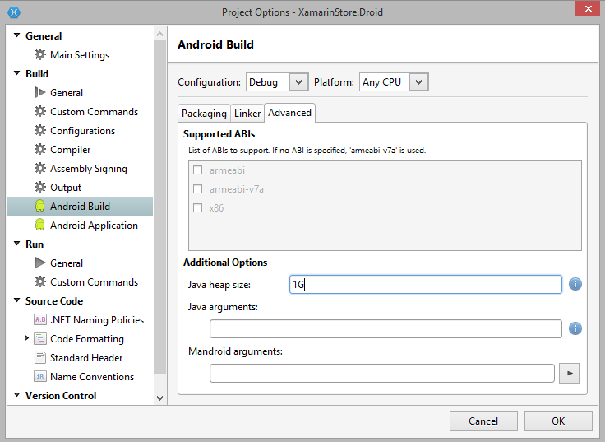

Set the Java heap size to 1GB

**Aapt error**

Usually occurs if you have (_) underscore or (-) for your image name in the in the Resources -> Drawables folder